|  |
| --- |
| **Title:**  System Audit Trail Review Report  **System:** External Access - BDS |
|  |
| **Approval** |

Nicole Wimmer (IMWWN), System Owner

Wolfgang Eichel (IMECL), Global Quality Unit

**Change History**

| **Version** | **Author** | **Description of Change** |
| --- | --- | --- |
| 001 | Nicole Wimmer (IMWWN) | Initial creation |
|  |  |  |

**Table of Contents**

1 Scope of this document 3

2 Basis for audit trail review 3

3 Audit trail for critical system configuration 3

3.1 Logging changes for upload of documents 3

3.2 Logging on SAP system parameter 4

4 Changes to roles and privileges 4

5 Changes to date and time settings 6

5.1 Time and date 6

5.2 Time Zones 6

6 Deletion of Data 6

6.1 Deletion of SD Documents 6

7 Conclusion & Action Summary 7

# Scope of this document

This document summarizes the results of the system audit trail review according to QMS-SOP-004 in BDS (Bayer document storage), former Doc41 WebUI. The review was conducted retroactively for one year.

# Basis for audit trail review

The periodic audit trail review should consider changes to critical system configurations, changes to roles and privileges, changes to time/date settings, deletion of data, and use of generic user IDs.

# Audit trail for critical system configuration

# Logging changes for upload of documents

Transaktion:

Action: Check, that the upload functionality is only possible for users with respectice actionclass

Der Upload im Spediteur-Portal wurde für die SD-Dokumententypen AWB, CMR und BOL angeboten. Diese Dokumententypen wurden in Doc41 vor etwa einem Jahr im Rahmen einer Bereinigung effektiv nicht genutzter Dokumenttypen deaktiviert. In BDS (dem Web-Frontend von Doc41 für externe Nutzer) haben wir in Folge allen Profilen die zugehörigen Rechte auf diese 3 Dokumenttypen entzogen, so dass für diese Dokumenttypen in BDS auch keine Funktionalität mehr angeboten wird.

Die Rechte hierfür wurden deaktiviert, was ich auch nochmal über unsere Profile-Permissions-Übersicht verifiziert habe.

Damit werden in BDS aktuell keine Upload-Funktionen (mehr) angeboten (auch nicht über das Spediteur-Portal-Interface).

Aktionsklassen externer Nutzer, die von der Applikation mitgeschrieben werden (sortiert nach ihrem letzten Auftreten, Produktion):

(Hier sieht man auch, dass der letzte UPLOAD am 05.04.2017 erfolgte, seither deaktiviert.)

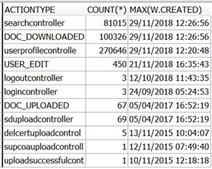

Measures: no measures required

# Logging on SAP system parameter

Vergleichbares für BDS???

It has to be ensured that the SAP Profile paramater are conform as described in GR 2059.

Action: Check P2R SAP Profile parameter changes arccording GR 2059 during time periode.

Record: Link to SSM Dokument

Evaluation:

Measures: No measures required

# Changes to roles and privileges

Changes to roles and privileges are subject to change management.

Action: Check changes to roles beside change management (w/o CRTs) and assignments which were done via Deployment.

Records: Only possible with database alter steps which need a deployment requested by change request. Alter steps are historized with the development repository of the application.

Extract:

Alter Step modifying Profile Permissions (executed on application deployments)

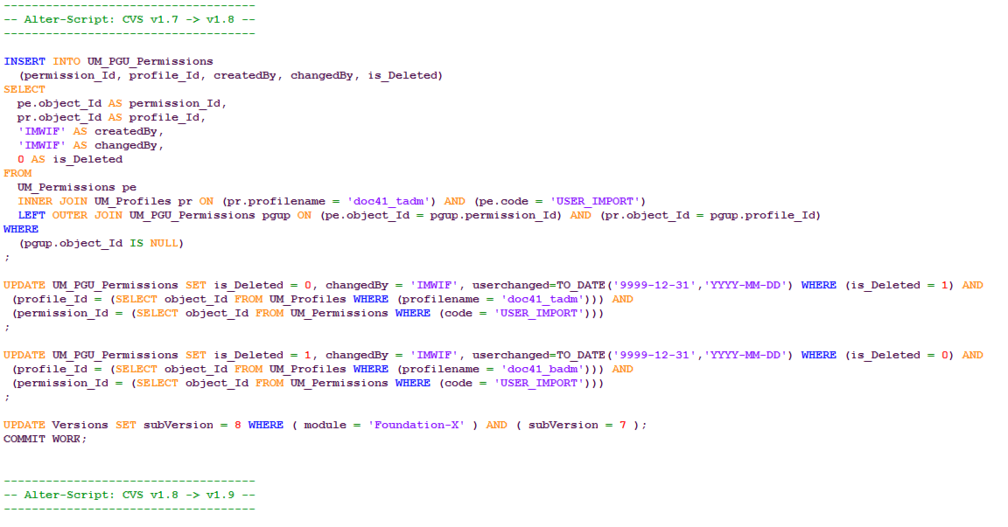

Documentation when the last Alter Step for a database was executed, who did the execution, when it was done and from which machine. Only database responsibles of the Application have the database access to do so.

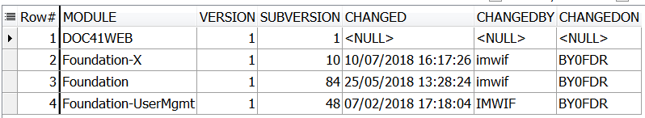

# Changes to date and time settings

# Time and date

BDS uses the time of the underlying operating system. BDS is synchronized with the NTP (Network Time Protocol) service. Metadata dates in BDS database tables are extra protected by Triggers.

Action: In case, the NTP service is not available, an alert will be trigger an incident which has to be checked in HPSM.

Records: no incidents in HPSM

Measures: No measures required

# Time Zones

Action: Check changes on timezone

Record: We only use UTC timzone all over the application. Timestamps are not shown to users. They are only part of database metadata and the logging of user actions.

Evaluation: No changes on setting timezone in the reviewed timeframe.

Measures: no measures required

# Deletion of Data

# Deletion of data

# in Oracle DB

# In Doc41

s. DIA Beschreibung

plus

Verweis auf 3.1., dass Upload Funktion nicht mehr möglich

The deletion of plant which has been used within a productive system is nearly impossible, due to the fact that a relational database is implemented. A precondition to enable the deletion of a plant would be to delete the master data and in particular the transactional data containing the plant.

For P2R, plants that are no longer used are marked with the prefix “zz_invalid”.

Measures: A report has to be created to review plants. This report will be created with CRT 2032728/3033656

# Conclusion & Action Summary

| **Action No.** | **Reference** | **Action** | **Priority\*** | **Implementation Control\*\*** |
| --- | --- | --- | --- | --- |
| 1 |  |  |  |  |
| 2 |  |  |  |  |
| 3 |  |  |  |  |
| 4 |  |  |  |  |
| 5 |  |  |  |  |
| 6 |  |  |  |  |
| 7 |  |  |  |  |
| 8 |  |  |  |  |
| 9 |  |  |  |  |
| 10 |  |  |  |  |

* 1: usually functional and/or procedural gaps  
2: usually documentation gaps  
immediate activity necessary: major deficiencies, e.g. data can be deleted or modified undetected

** CAPAs stored in Dev@Com related to deviation report xxx